
PROJECT PROPOSAL





Signature

Short Description:
The Book Ordering System is an online platform for browsing, purchasing, and managing books. It features a user-friendly interface for customers and an Admin Panel for inventory and order management.

Supervised By:

Ms. Meher Afroj.
Assistant Professor,
Dept of Department of Computer Science & Engineering, BUBT.

BOOK ORDERING SYSTEM




ABOUT US
We are the students of Dept of CSE from Bangladesh University of Business & Technology.

Participants Are:
- Rohan Rashid. ID: 21222203050
- Istiak Ahmed Arnob. ID: 21222203028
- Bikash Chandra Ray. ID: 21222203045
- Md. Imran Hossen. ID: 21222203001
- Rajesh Chandra Barman. ID: 21222203002

ABOUT PROJECT

Project Overview

This proposal outlines the development of a Book Ordering System designed to streamline the process of browsing, selecting, and purchasing books online. The system will have two primary interfaces: the User Panel and the Admin Panel. The User Panel allows customers to browse categorized books, add them to their cart, and complete purchases. The Admin Panel enables administrators to manage book inventory, handle user information, and maintain system operations.

Objectives
The primary objectives of the Book Ordering System are as follows:
- User-Friendly Shopping Experience**: Provide an intuitive interface for users to browse categorized books, add them to their cart, and complete purchases seamlessly.
- Efficient Book Management**: Enable admins to easily add, update, or delete books from the inventory.
- Order Processing**: Streamline the checkout process, including payment and delivery information, to ensure accurate and timely order fulfillment.
- Admin Control**: Offer a secure Admin Panel for managing user information, book listings, and order statuses.
- Responsive Design**: Ensure the platform is accessible and functional across various devices and screen sizes..

Activity Diagram
The activity diagram represents the activity structure, illustrating the relationships, and attributes involved in the Book Ordering System:
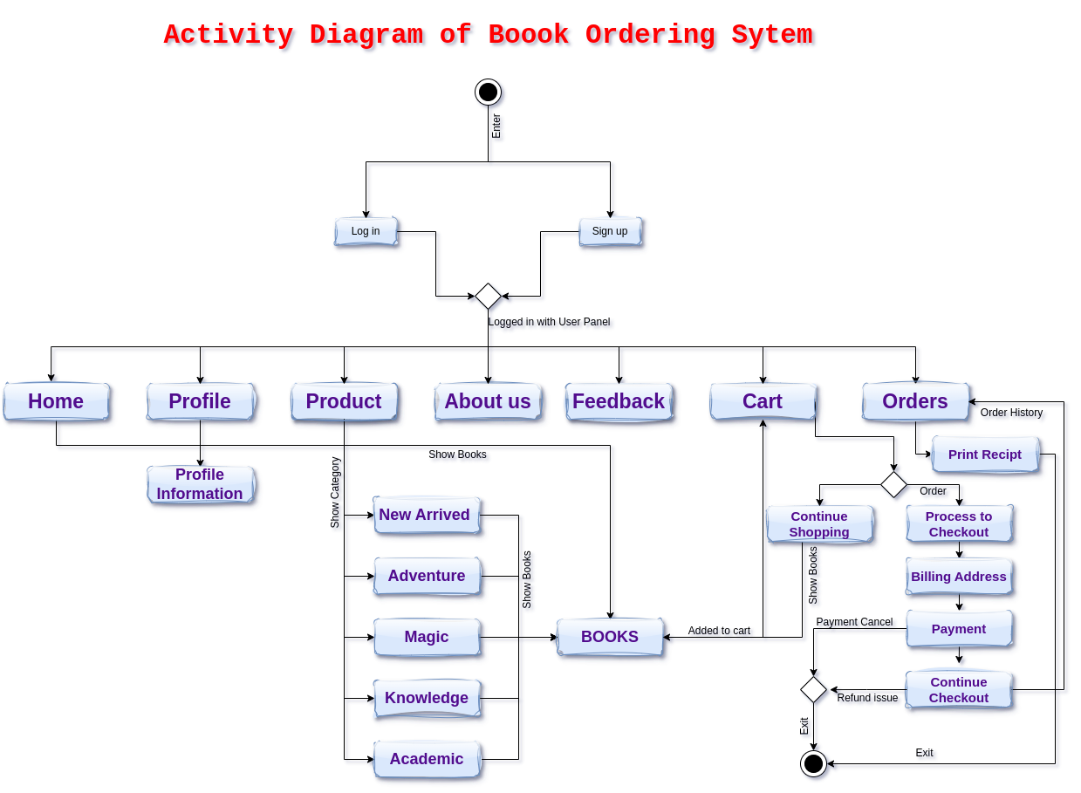

This activity diagram represents a Book Ordering System (BOS), which visualizes the step-by-step process of purchasing a book through an online system. Here's a detailed explanation of the customer journey:

Entry Point: The customer starts by entering the system (shown as the black circle).

Log In or Sign Up:

If the customer already has an account, they proceed to "Log in."

If they are new, they select "Sign up" to create a new account.

Logged-in Status: Once logged in, the system presents the user panel with multiple options, such as Home, Profile, Product, About Us, Feedback, Cart, and Orders.

Navigation Options:

The customer can select any option based on their needs. For instance:

Home: Returns to the home page.

Profile: Shows profile information like the customer’s personal details.

Product: Opens the catalog of books for purchase.

About Us and Feedback: Offer information about the company or a way to provide feedback.

Cart: Opens the shopping cart to view added items.

Orders: Provides access to order history and receipts.

Product Browsing:

When selecting the Product option, the system shows categories like New Arrived, Adventure, Magic, Knowledge, and Academic books.

The customer selects a category to view relevant books.

Adding to Cart:

After selecting a book (under the "Books" node), the system adds it to the cart for purchasing.

Cart Options:

From the Cart, the customer can:

Continue Shopping to add more items.

Proceed to Checkout to finalize the order.

Checkout Process:

The customer fills in the Billing Address.

The next step is Payment.

If the payment is successful, they proceed to receive the receipt.

If there is a Payment Issue, the customer can retry or choose a different payment method.

Completion:

After successful payment, the customer reaches the final stage where they can print the receipt.

If there's an issue or the customer decides to cancel the payment, a Refund is initiated.

The transaction process ends when everything is completed successfully (shown as the circle at the bottom).

This diagram outlines how a customer navigates through a book ordering system, from browsing to purchasing, handling payment issues, and finalizing the order.

Use Case Diagram:

here's a Use Case Diagram with the necessary components like actors, use cases, relationships, system boundary, and generalization relationships

Key Elements in the Diagram:

Actors:

WebCustomer: General actor representing all types of users.

RegisteredCustomer: A user who is already registered.

NewCustomer: A user who needs to register.

Authentication Service, Identity Provider: External services for user verification.

Credit Payment Service, PayPal: External services for processing payments.

Use Cases:

View Items: Browsing available books.

Make Purchase: Buying a book, includes View Items.

Checkout: Finalizing the purchase, includes Make Purchase.

Client Register: Registering a new customer.

Relationships:

Generalization:

RegisteredCustomer and NewCustomer are specialized versions of the WebCustomer.

Include Relationship:

Make Purchase includes View Items.

Checkout includes Make Purchase.

Association:

WebCustomer can view items.

RegisteredCustomer can make a purchase and checkout.

NewCustomer can register.

Service Interactions:

Authentication Service is involved in Client Register and Checkout.

Identity Provider supports Client Register and Make Purchase.

Credit Payment Service and PayPal are used in Checkout for payment processing.

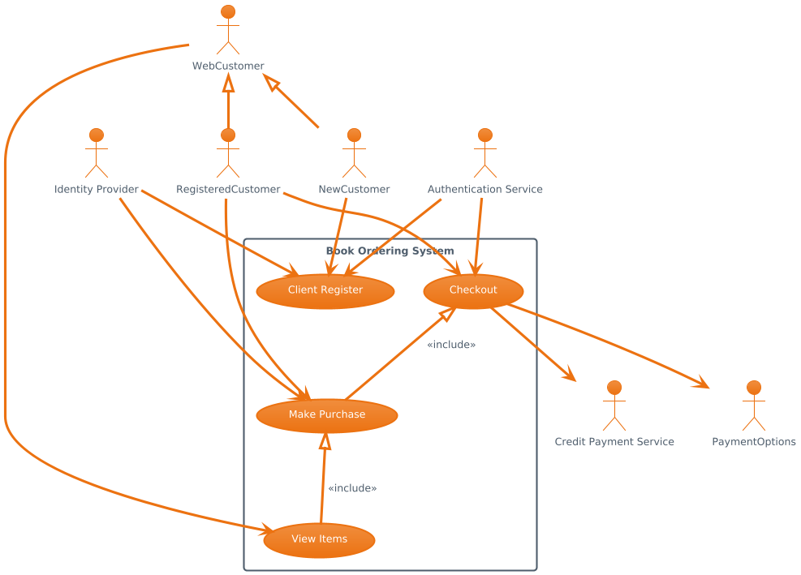Use Case Diagram of Book Ordering system

How It Works:

A WebCustomer can be either a RegisteredCustomer or a NewCustomer.

NewCustomer needs to register, which involves authentication and identity verification.

Both RegisteredCustomer and WebCustomer can view items.

Only RegisteredCustomer can make a purchase and checkout, with external payment services like CreditService and PayPal for handling payments.

Class Diagram:

This class diagram defines how the Book Ordering System components interact with each other, such as how users can add books to a cart, place an order, and make payments.

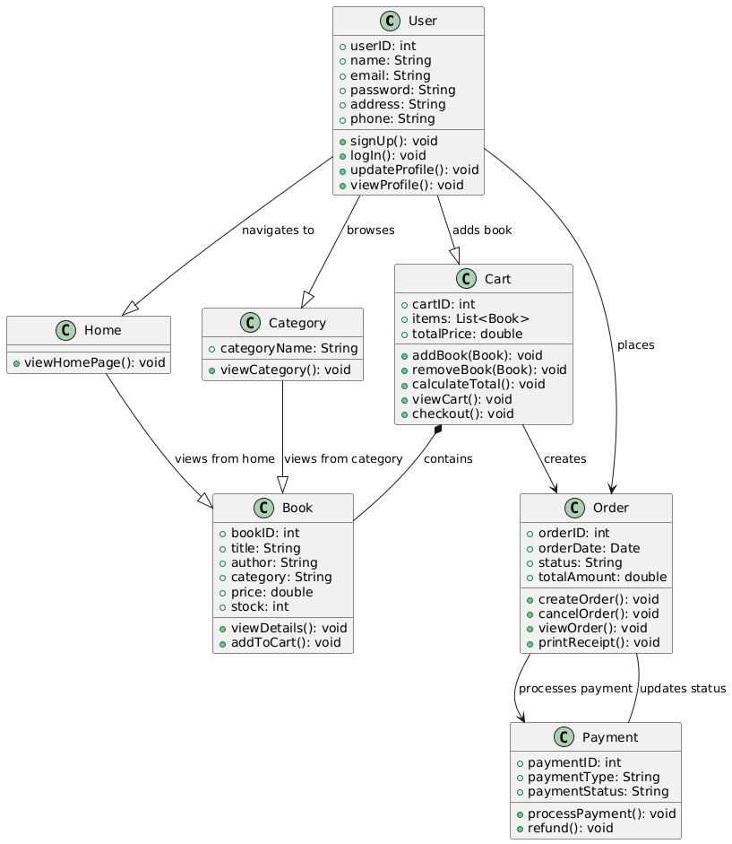

Features
The Book Ordering System will incorporate the following features:
- User Management: Different roles (Administrator, User) with specific access levels and permissions.
- Book Browsing: Users can browse and filter books by category, author, or title.
- Shopping Cart: Add books to the cart and manage quantities before checkout.
- Checkout Process: Enter delivery and payment information to complete purchases.
- Admin Management: Admins can add, update, or delete books and manage orders.
- Order Tracking: Admins can view and update the status of orders.
- Responsive Design: Ensure the platform works seamlessly across various devices and screen sizes.
- Security and Privacy: Implement secure access controls to protect user and transaction data.

Technology Stack
The proposed technology stack for the Book Ordering System includes:
- Frontend: HTML, CSS
- Backend: JavaScript (for future development)
- Database: SQL/NoSQL (for future development)
TimelinePlanning and Requirements Gathering: 2 weeks
- Database Design and Schema Implementation: 2 weeks
- Back-End Development: 3 weeks
- Front-End Development: 3 weeks
- Testing and Quality Assurance: 1 weeks
- Deployment and Training: 2 weeks
- Post-launch Support and Maintenance: Ongoing

Budget
The budget for the project will depend on various factors, including the development team's size, the complexity of the system, and any additional features. A detailed cost estimation will be provided after further analysis.
Conclusion
The proposed Book Ordering System will offer a comprehensive solution for both users and administrators to manage and purchase books efficiently. The clear separation between the User and Admin Panels ensures a streamlined experience for customers and an effective management interface for administrators. Future enhancements will further improve the system's functionality and user experience.

